Phonics at Christ Church C of E Aided Primary School

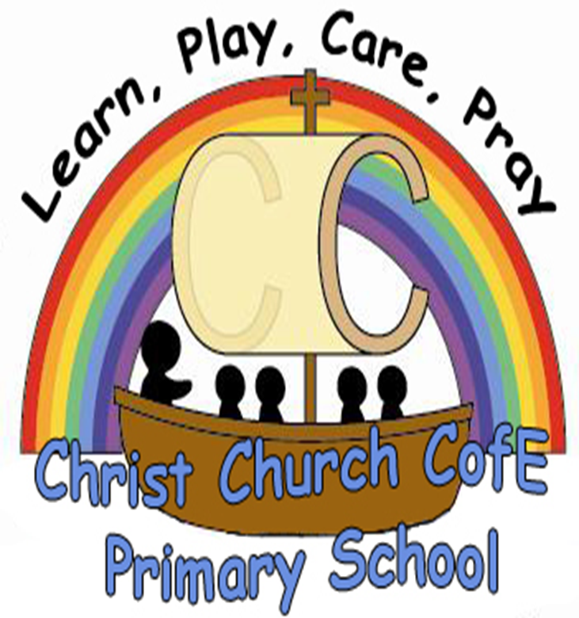

A guide for parents

Phonics at Christ Church Primary School

Introduction
At Christ Church we know how important it is for parents and teachers to work together to give your child the best start. Reading together at home is one of the most effective and important ways in which you can help your child. Children should be encouraged to enjoy sharing books and read independently, as well as reading with an adult. This not only supports children’s progression in reading but leads to them seeing reading as a source of pleasure and interest.

To support your child in becoming an effective and confident reader we hope to work with you to develop their knowledge of phonics (letter sounds) to enable them to decode different words they may come across.

Through this booklet we hope to give you an overview of phonics teaching with your child, and some ideas for how you can support your child at home.

What is Phonics?
The alphabet contains only 26 letters. Spoken English uses about 44 sounds (phonemes). These phonemes are represented by letters (graphemes). In other words, a sound can be represented by a letter (e.g. ‘e’ or ‘p’) or a group of letters (e.g. ‘sh’ or ‘air’).
A letter consists of: a sound, a shape and it has a capital form and a lower case form.

The letter sound is the first thing that children need to
recognise.

Aa

Use lower case letters for all other writing.

Letter shape= grapheme.
Letter sound= phoneme.

Letters and Sounds
We are following Government guidance which refers to 6 phases of Phonics teaching (The Letters and Sounds programme). The six phase teaching programme focuses on high quality phonics work. The intention is to ‘equip children who are aged 5 with the phonic knowledge and skills they need to become fluent readers by the age of 7.’ By the end of Year Two children should have completed phase 6. The teacher assesses which phase the children should be working on, and appropriate teaching is planned for.

We use Ruth Miskin Read Write Inc. resources to support our phonics teaching.

The Phases
Phase One
The aim of Phase One aims to develop children’s listening and speaking skills as preparation for learning to read and spell with phonics. Children explore and experiment with sounds and become familiar with rhyme, rhythm and alliteration. Parents can play a vital role in helping their children develop these skills by encouraging them to listen carefully and talk extensively about what they hear, see and do.

This continues throughout their Primary Education.
Phase Two
Phase Two introduces grapheme/phoneme (letter/sound) correspondence. Children learn that words are constructed from phonemes and that phonemes are represented by graphemes. They begin with a small selection of common consonants and vowels (s, a, t, p, i, n) and begin to put them together to read and spell CVC words (consonant vowel consonant).
E.g. c-a-t s-i-t p-a-n

Phase Three
Phase Three teaches children one grapheme for each of the 44 phonemes in order to read and spell simple regular words. Children link sounds to letters, naming and sounding the letters of the alphabet. They hear and say sounds in the order they occur in the word and read simple words by blending the phonemes from left to right. They recognise common digraphs (1 sound 2 letters e.g. th) and read some high frequency words.
E.g. sh-e-ll b-oa-t t-r-ai-n

Phase Four
Phase Four teaches children to read and spell words containing adjacent consonants. Children will be able to blend and segment these words and apply this skill when reading and spelling. They move from CVC words (pot) to CVCC words (pots) and CCVC words (spot) and then CCVCC words (spots). They will also explore polysyllabic words (shampoo, helper).

Phase Five
Phase Five teaches children to use alternative ways of pronouncing the graphemes and spelling the phonemes already taught. For example they will learn that the phoneme ‘ai’ can be spelt ‘ai’, ‘ay’ ‘ey’ and a_e’. They will also learn that ‘c’ can be pronounced ‘c’ in coat or ‘c’ in city.

Phase Six
Phase Six teaches children to develop their skills and automaticity in reading and spelling, creating an ever increasing capacity to attend to reading for meaning. They apply phonics knowledge to recognise and spell an increasing number of complex words.

Blending for Reading
To learn to read and spell children must be able to smoothly blend sounds together. Blending sounds fluidly helps to improve fluency when reading. Blending is more difficult to do with longer words so learning how to blend accurately at an early age is imperative. Showing your child how to blend is important. Model how to ‘sound talk’ sounds and blend them smoothly together without stopping at each individual sound. We use our fingers to support this.

Remember some sounds (digraphs) are resented by two letters, such as ee or oi. Children should sound out the digraph not the individual letters (e.g. oi not o-i). Some words may also have trigraphs, three letters to represent one sound, (.e.g. h-ear or p-air.).

Try these words:
Plant p-l-a-n-t
Sheep sh– ee-p
Explain e-x-p-l-ai-n

Segmenting to Spell
Segmenting is a skill used in spelling. In order to spell the word it is necessary to segment the word into its constituent sounds. E.g. ran r-a-n.

Start by having your child listen for the first sound in a word (games like i-spy are ideal). Next try listening for the end sounds and then the middle sounds (middle sounds are hardest to hear). Begin with simple three-letters words (e.g. tap or hot) and build it up. Take care with digraphs, the word fish, for example, has four letters but only three sounds f-i-sh. Rhyming games and poems also help tune the ears to the sounds in words.
Strategy for spelling
Encourage children to think the word, say it several times and then write it.

Tricky words
Tricky words are words that cannot be ‘sounded-out’ but need to be learnt by heart. They don’t fit into usual spelling patterns. When learning these words it is important for children to start with the familiar sounds and then notice the ‘tricky’ bits.

High Frequency Words
These are words that recur frequently in much of the written materials young children read and need to write.

The phonemes/graphemes
We use the Ruth Miskin Read Write Inc. resources to introduce the phonemes/graphemes. The digraphs come with a little ‘ditty’ to help the children remember them. This is the order in which they are taught:

s a t p i n m d g o c k ck e u r h b f ff l ll ss
j v w x y z zz qu ch sh

th- this and that
ng- a thing on a string
ai– snail in the rain
ee– what can you see?
igh– fly high
oa– goat in a boat
oo– poo at the zoo
oo– look at a book
ar– start the car
or– shut the door
ur– nurse with a purse
ow– brown cow
oi– spoil the boy
ear– hear with your ear
air– that’s not fair
ure– sure it’s pure
er– a better letter
ay– may I play
ou– shout it out
ie– I cried
ea– cup of tea
oy– toy for a boy
ir– whirl and twirl
ue– true blue
aw– yawn at dawn
wh– what do you want
ph- a dolphin
ew– chew the stew
oe– touch your toe
au– a haunted house woooo
ey– cheeky monkey
a-e– make a cake
e-e– these are ee’s
i-e- nice smile
o-e– phone home
u-e– huge brute

Games to play at home
Hoop Game
Get 2 hoops, trays or plates and place a letter card on each of them e.g. s and a. Have a variety of objects beginning with these 2 sounds. Ask your child to select an object and say the name of it. Repeat it several times and then ask your child to place it on the correct tray.

Sound Hunt
Encourage children to hunt around the house or garden for objects beginning with a certain sound. This can also be done with words hidden around the house.

Rogue Sound Game
Show a variety of objects to your child. All of the objects have the same initial sound except one. Ask them to identify the rogue item.

Bingo
Bingo board can be easily made and differentiated. Put letters, digraphs, words etc. in 6 spaces and make 6 cards that match. Can your child match them? Can they be the ‘bingo caller’ and say what is on the card first?

Letters/graphemes in the mud
Encourage children to write letters/graphemes in different ways. Write them with a stick in the mud, with their finger in sand, a straw in paint. This is not only great for their sound/ letter correspondence but also for handwriting.

Treasure/Trash
Make some word cards with real and nonsense words using a variety of graphemes. Decode the word together, blend and decide if it is a real ‘treasure’ word or a ‘trash’ nonsense word (which can go in the bin).

Useful Websites
There are lots of fantastic websites to support the learning of Phonics, lots have super games that the children love to play.

www.phonicsplay.co.uk
www.galacticphonics.com
www.oxfordowl.co.uk
www.ictgames.co.uk
www.espresso.co.uk (password required – not supplied by school)

